|  |
| --- |
| Web Fundamentals Checkpoint Project |

* *How does the web works*?
* How does the Internet work? Good question! The Internet's growth has become explosive and it seems impossible to escape the bombardment of *www.com*'s seen constantly on television, heard on radio, and seen in magazines. Because the Internet has become such a large part of our lives, a good understanding is needed to use this new tool most effectively.

**Web** pages are written in text with Hypertext Markup Language (HTML), then uploaded to a host computer running **web** server software, such as Apache or Microsoft's IIS (**Internet** Information Server). ... The host and client communicate using an agreed 'language' called HTTP (HyperText Transfer Protocol).

* *What*do you need*to be a web developer?*
* User experience (UX)
* User interface (UI)
* Visual design.
* Coding languages including HTML and CSS.
* Frontend **web** programing languages and skills such as JavaScript, Ajax and **web** animation techniques.
* Backend **web** programing languages such as C# or Java, PHP and Ruby.

Key skills to be successful in web development include:

* Computer literacy
* Strong numeracy skills
* Strong creative ability
* Attention to detail
* Strong communication skills
* Excellent problem-solving skills
* A logical approach to work
* The ability to explain technical matters clearly
* A keen interest in technology

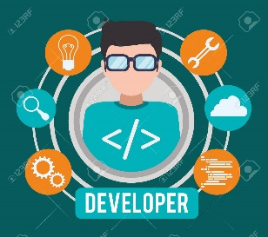

* *What’s the role of a web developer*
* A **Web Developer** is responsible for the coding, **design** and layout of a **website** according to a company's specifications. As the **role** takes into consideration user experience and **function**, a certain level of both graphic **design** and computer programming is necessary.